***Assignment 4***

* **Problem statement:** Create a private bucket in AWS. Upload a file and checked by reassigned URL whether you can access the file or not
* **Steps :**

1. Sign in into AWS account and go to the S3 tab

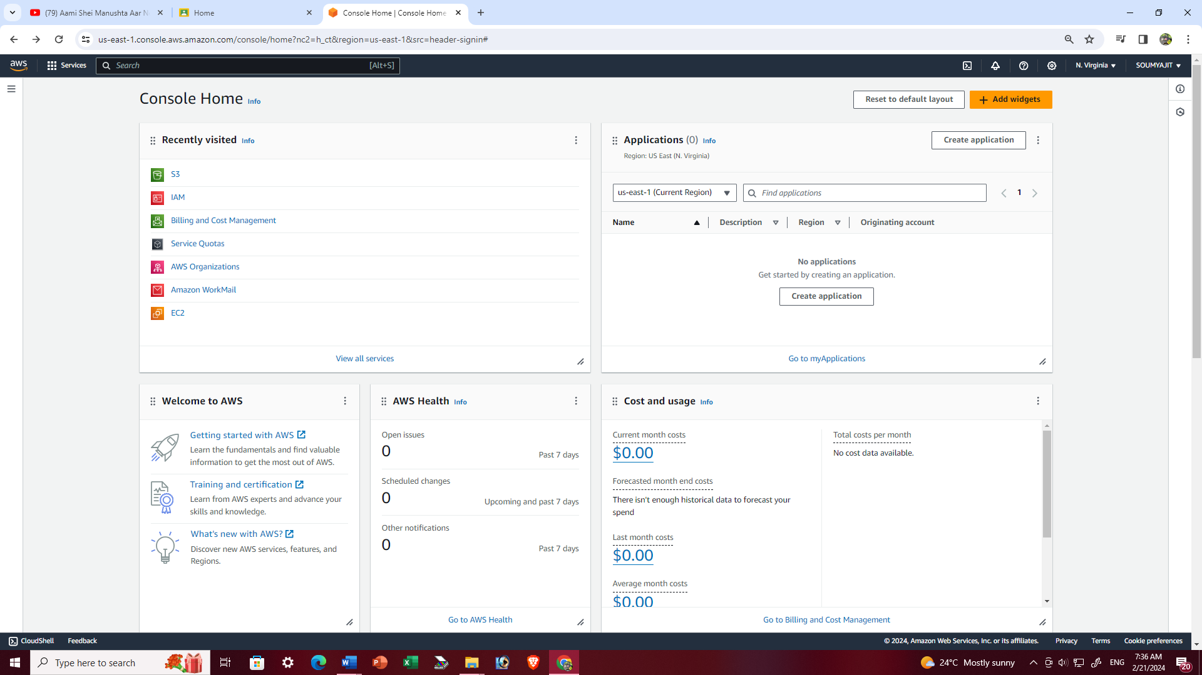

1. Click on the “create bucket option”

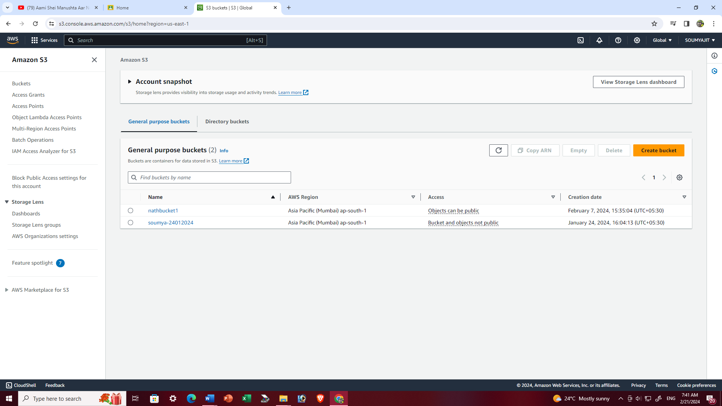

1. Fill up the required details->’AWS region’ , ‘Bucket name’ then we have to do ‘ALC disabled’ because we are creating a private bucket and check the other configuration as per the snapshots then click on ‘Create bucket’.

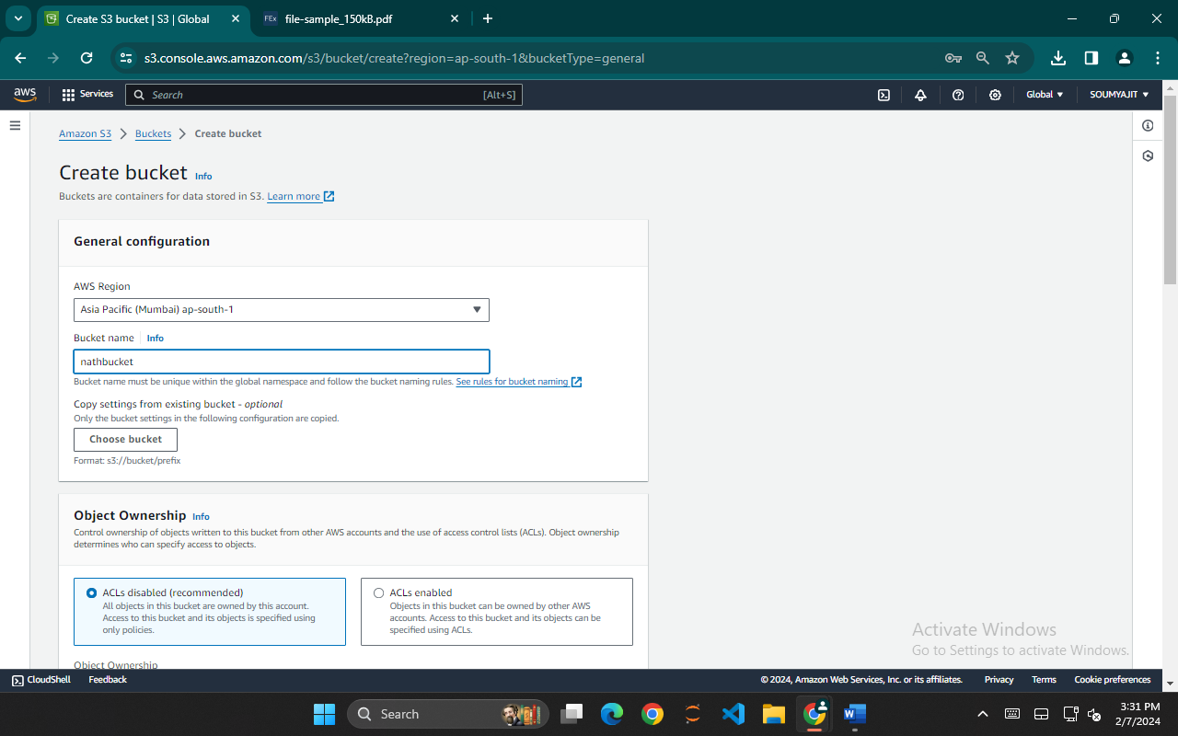

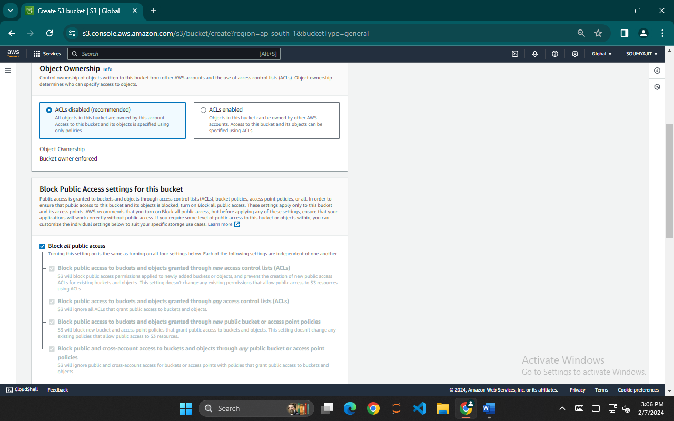

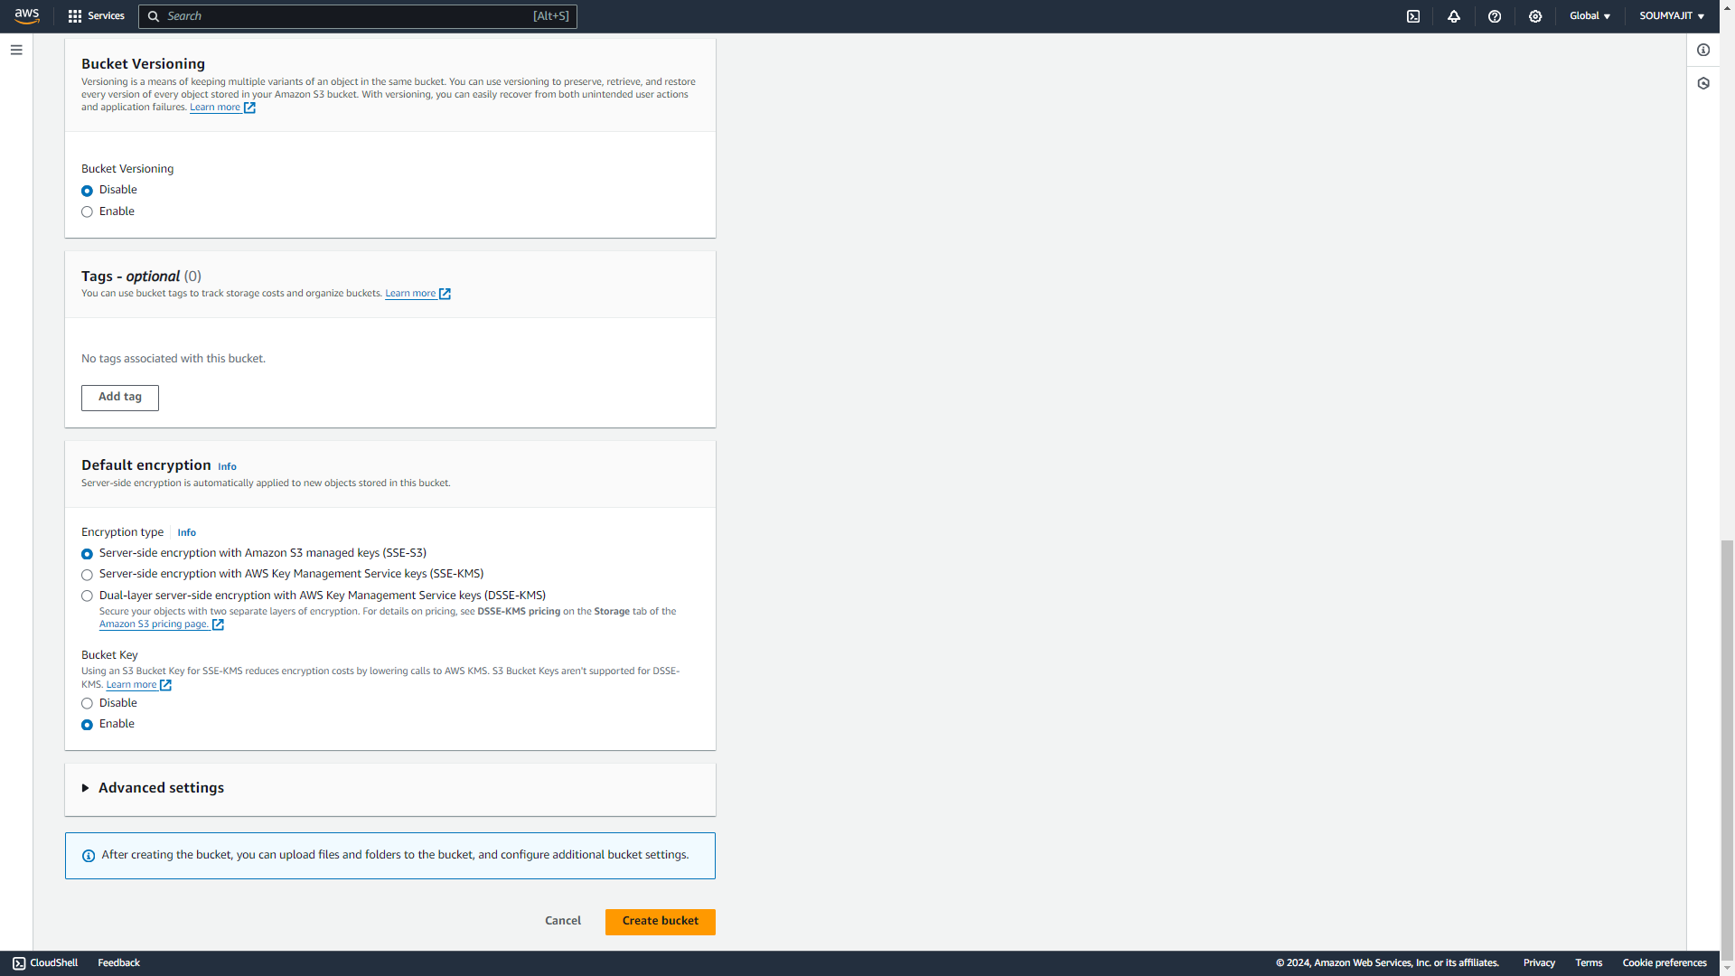

1. ‘nathbucket’ bucket is created successfully then click on bucket name ‘nathbucket’

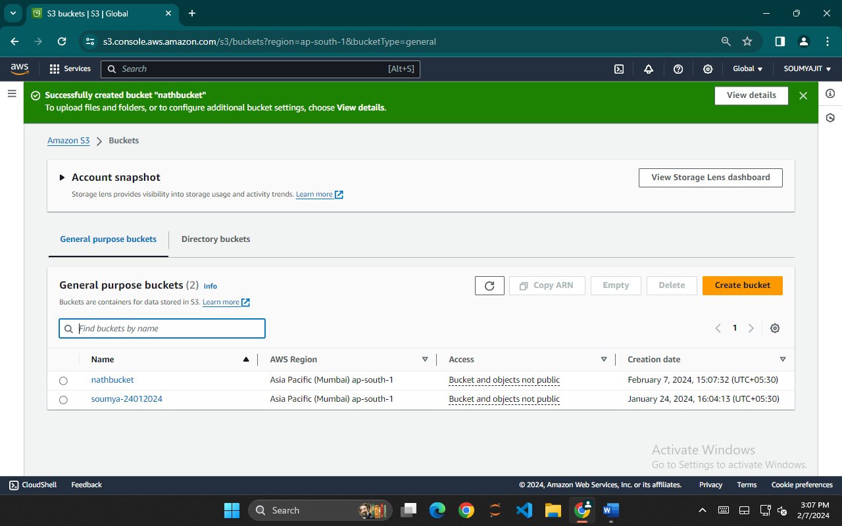

1. Under ‘nathbucket’ click on ‘Upload’ then choose a file of your choice for uploading.

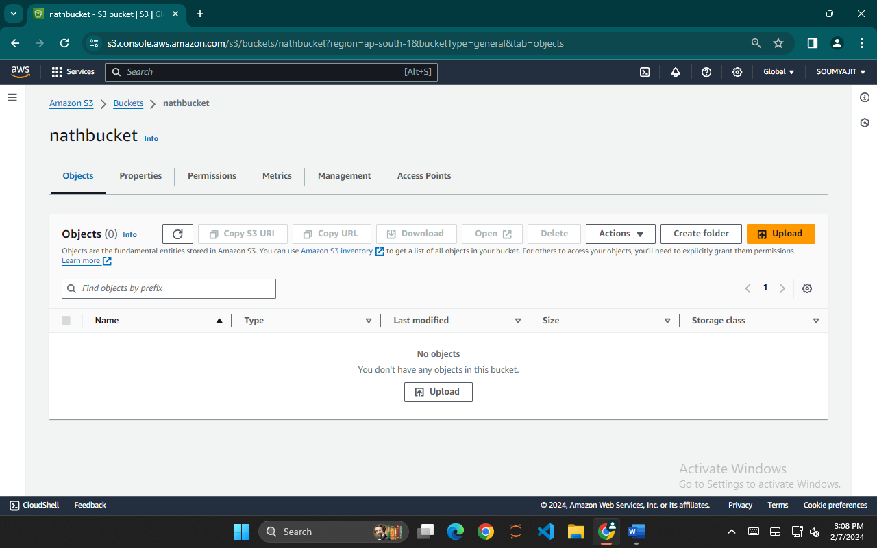

1. Click on ‘Add files’ then tick off the ‘Name’ of the file and click on ‘Upload’.

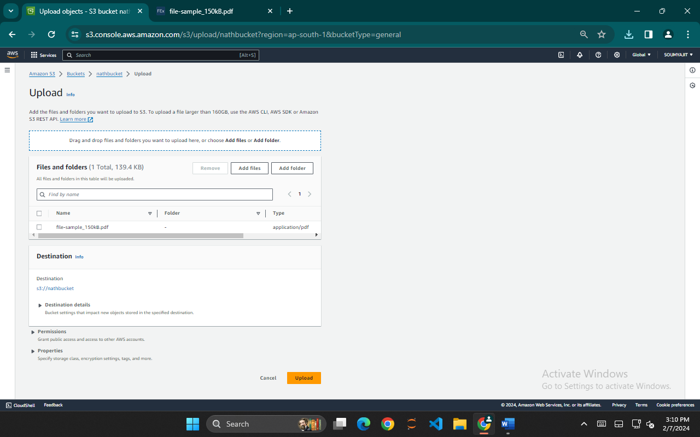

1. File is uploaded successfully , tap on ‘Close’ and click on ‘Name’.

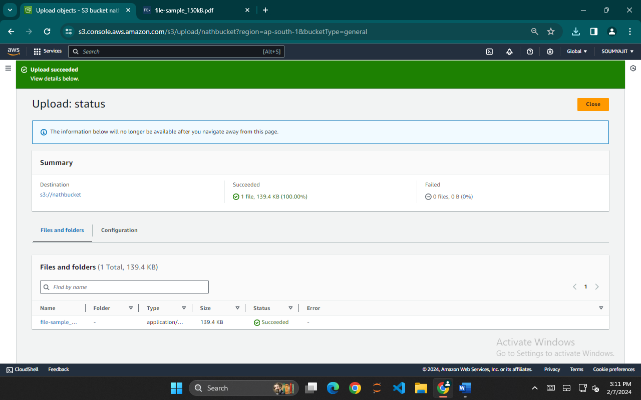

1. Under ‘Name’ tick off any one of the files(checkbox) and click on that file.

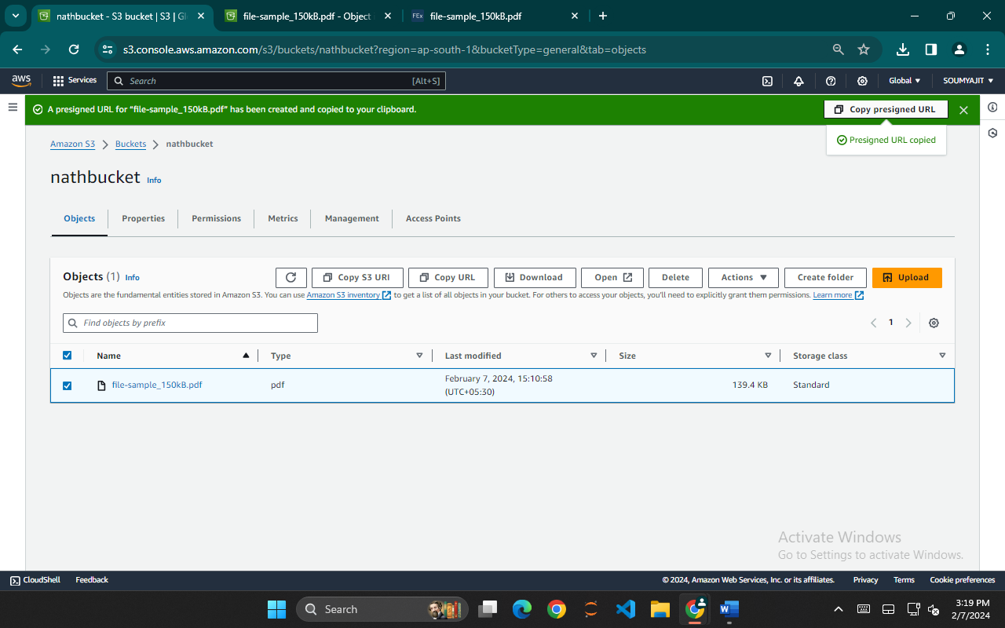

1. Copy the ‘Object URL’.

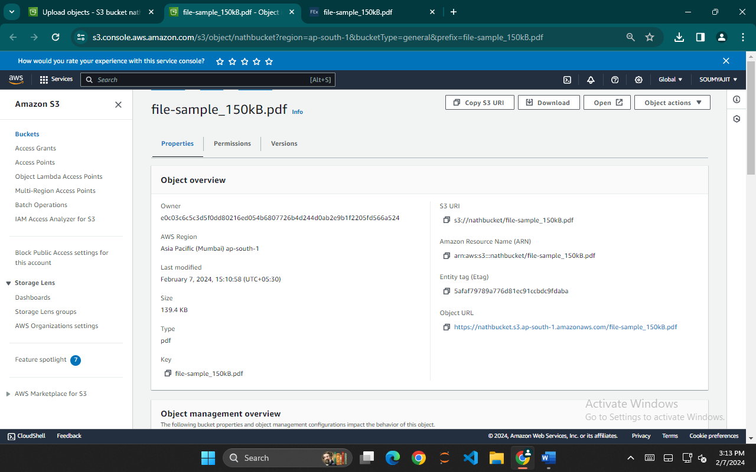

1. Now open the ‘Incognito mode’ and paste the ‘Object URL’. We will see that the file cannot be accessed as it was a private bucket.

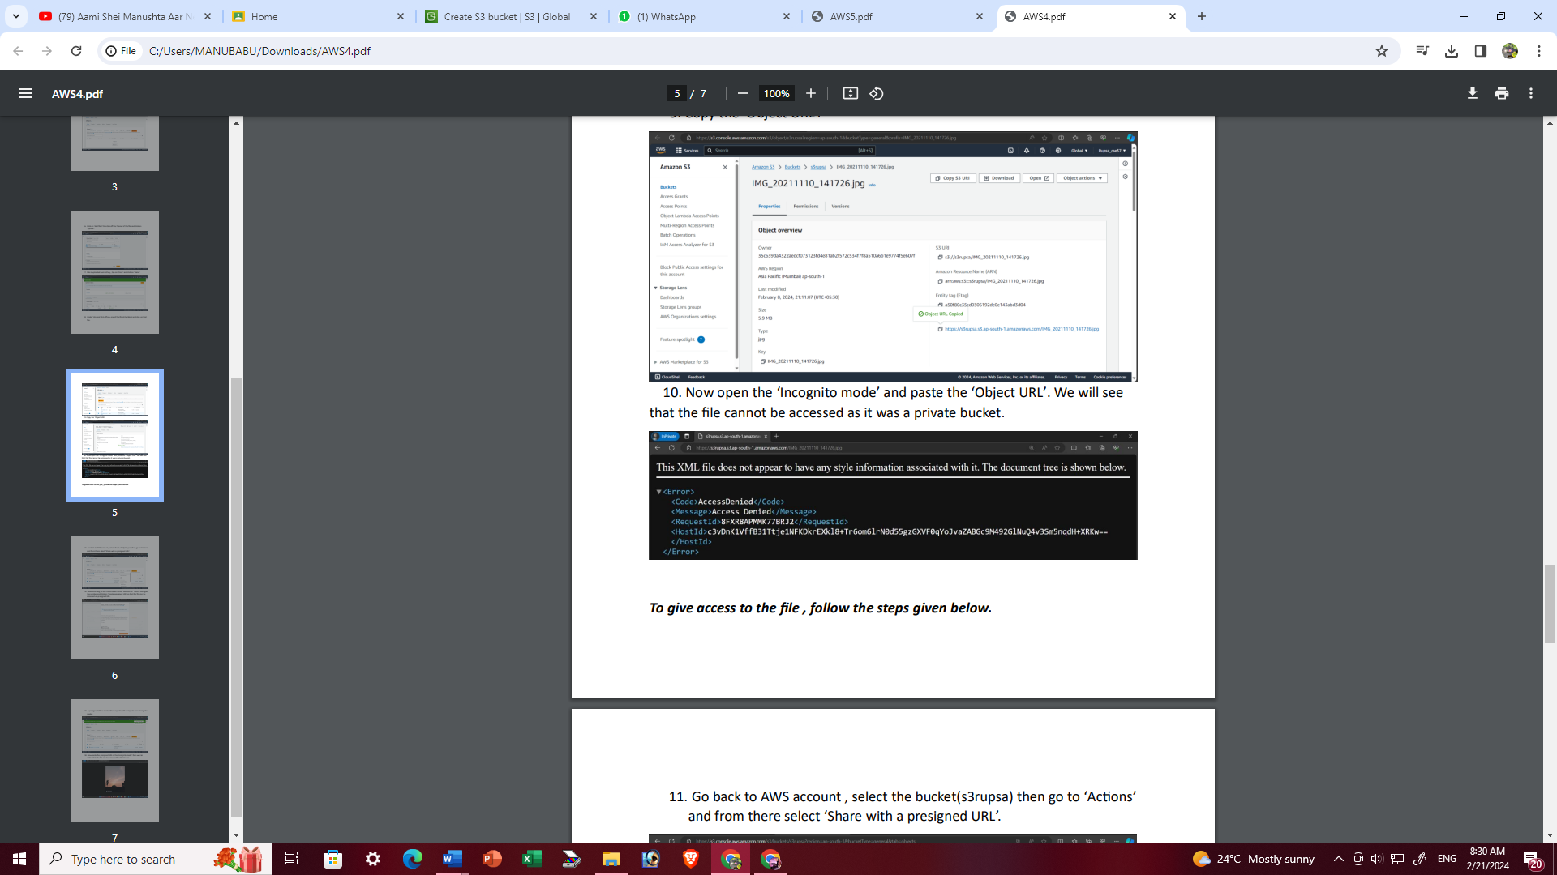

1. Go back to AWS account , select the bucket then go to ‘Actions’ and from there select ‘Share with a presigned URL’.

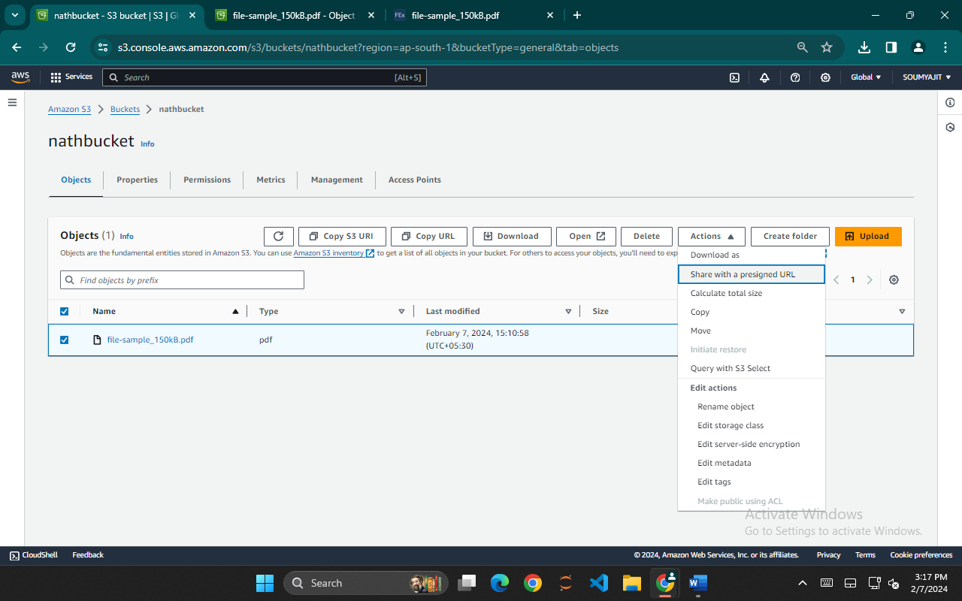

1. Now according to our choice select either ‘Minutes’ or ‘Hours’ then how much time we can access and click on ‘Create presigned URL’

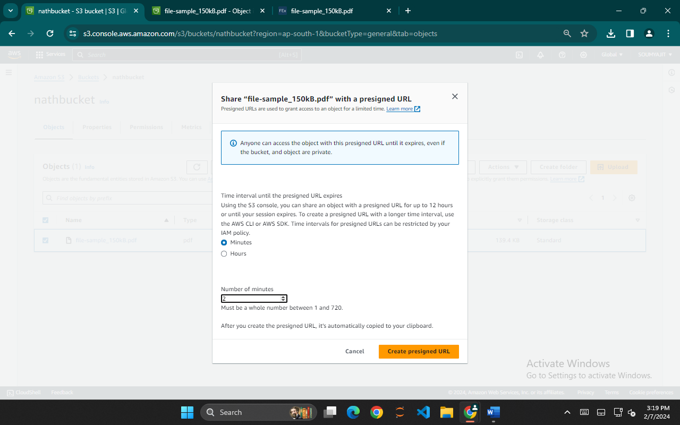

1. Copy the presigned URL and paste it on ‘Incognito mode’



1. Now paste the presigned URL in the ‘Incognito mode’ then we can notice that the file can be accessed or visible for 2 minutes.

